AVENBURY CARE FARM

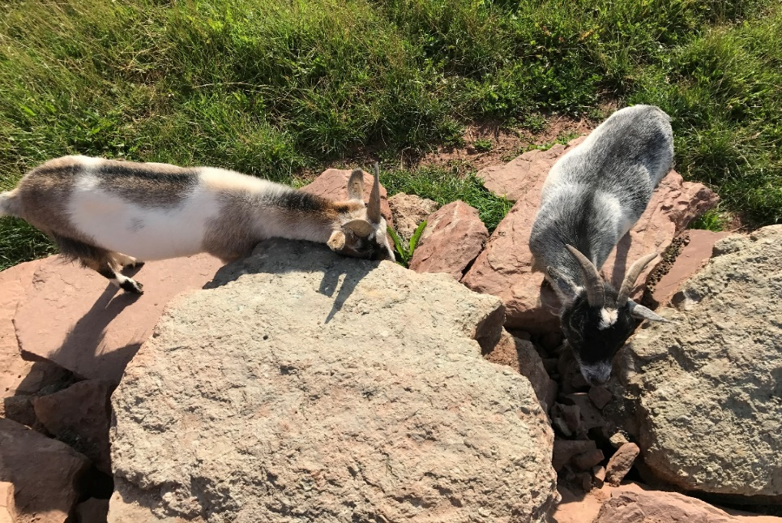

5/2/2018 |  |  | ANIMAL WELFARE POLICY
Avenbury Care Farm is committed to comply with UK and/or EU animal welfare legislation including statutory livestock codes of practice, the Animal Welfare Act, The Welfare of Farm Animals Regulations and EU Council Regulation and Directives relating to specific animal welfare standards for each species.

The Animal Welfare Act 2007 lists the Five Freedoms as:
- Freedom from hunger and thirst by ready access to fresh water and a diet to maintain full health and vigor.
- Freedom from discomfort by providing an appropriate environment including shelter and a comfortable resting area.
- Freedom from pain, injury or disease by prevention or rapid diagnosis and treatment.
- Freedom to express normal behaviour by providing sufficient space, proper facilities and company of the animal’s own kind.
- Freedom from fear and distress by ensuring conditions and treatment which avoid mental suffering.

Farm Animal Welfare Committee: All farm animals should enjoy a good life and at a minimum they must live a life worth living.
The welfare of an animal includes its physical and mental state and good animal welfare implies both fitness and a sense of well-being.

Content page
Goats 4
Chicken 6
Ponies 8
Rabbits 10
Sheep 12
Pigs 14
Alpacas 16

Keeping Goats – Welfare

Bedding:
Straw or a similar material should be used to provide a dry comfortable lying area.
Bedding should be ‘poo picked’ daily (fecal matter and urinated areas should be cleaned out daily). The whole enclosure should be full cleaned weekly. Animals must not be in the enclosure when being cleaned out to prevent hazards.

Diet and water:
All goats are browsers.
An acre of grassland is sufficient for at least 5 goats. If you don’t have enough grass, you can easily keep them on a smaller field and feed them extra feeding pellets, supplemented with hay and vegetable leaves ( lettuce, leaves).
It is important not to stick to these guidelines too tightly. At some point, you should be able to feed them according to your eye. As soon as your goat starts getting too fat, feed it less. A goat that is too fat, is an unhealthy goat.
Water should be changed in the morning and afternoon; before the goats are put back in their enclosures. Food should be given in morning and afternoon.

Enrichment:
Goats love treats, climbing frames and parkour. A good form of enrichment is treats hidden in toys. Constructing climbing frames for them to play on.

Handling:
- Leash training- you can either use a lead and collar or a harness.
- Grooming- Use a soft brush to brush the goats fur.

Behaviour:
Normal behaviour:
Social behaviours, browsing, bleating, knocking horns, scratching against rocks and fence, huddling when cold, sleeping, urinating and excreting.

Abnormal behaviour:
Huddling in a small space, eating too much or too little, isolating itself for long periods of time.

Condition of the environment:
Outdoor- grassy areas, water troughs spotted about, sturdy fencing, parkour
Indoor- well ventilated, draft free, thick layer of straw, no sharp objects or corners.

Environment size (enclosure parameters):
13x13ft, 6.5 ft tall.

Relevant legislations:
Animal Welfare Act 2006
COSHH
RIDDOR

Health care:
Health checking, administering medication, weighing, hoof trimming. Hygiene colour coded system- goats are green; all equipment such as wheel barrow, brushes, muck fork etc., are green

Outdoor enclosure:
24x40 meters roughly. Field shelter, balls to play with, Rocks to climb

Keeping Chickens – Welfare

Bedding:
A thick layer of shavings should be used as bedding.
Bedding should be ‘poo picked’ daily (fecal matter and urinated areas should be cleaned out daily). The whole enclosure should be full cleaned weekly. Chickens must not be in enclosure when being cleaned out to prevent hazards.

Diet and water:
Water should be changed in the morning and afternoon; before the chickens are put back in their enclosure. Corn and layers pellets should be given in morning and afternoon. Grit should be available at all times.

Enrichment:
Dust baths, climbing/ perching areas, mirrors, swings, hanging vegetables.

Handling:
- Restrain to put mite treatment on, health checks, worming.

Behaviour:
Normal behaviour:
social behaviours, foraging, dust bathing, foraging, huddling when cold, sleeping, urinating and excreting, eating and drinking.

Abnormal behaviour:
not moving at all, feather loss, not eating or drinking.

Condition of the environment:
Outdoor- grassy areas, dust bath areas, shelters, water troughs spotted about, sturdy fencing.
Indoor- well ventilated, draft free, thick layer of shavings, no sharp objects or corners.

Environment size (enclosure parameters):
13x13ft, 6.5 ft tall.

Relevant legislations:
Animal Welfare Act 2006
COSHH
RIDDOR

Health care:
Health checking, administering medication, weighing. Hygiene colour coded system- chickens are red; all equipment such as wheel borough, brushes, muck fork etc… will be red.

Outdoor enclosure:
24x40 meters roughly. Shelters spotted round, enrichment spotted around.

Keeping Ponies – Welfare

Bedding:
A thick layer of straw will be used.
Bedding should be ‘poo picked’ daily (fecal matter and urinated areas should be cleaned out daily). The whole enclosure should be full cleaned weekly. Ponies must not be in enclosure when being cleaned out to prevent hazards.

Diet and water:
Water should be changed in the morning and afternoon; before the ponies are put back in their enclosures.
Haylage will be used in hay nets in the afternoon, and bucket feed will be given in the afternoon; this consists of chaff and pasture mix and slices of fruit.

Enrichment:
Ponies love toys. A good form of enrichment is treats hidden in toys, Balls, salt licks etc…

Handling:
- Head collar and lead rope, saddle, bridle, rug.
- Grooming- The ponies will be groomed daily with a dandy brush, body brush, hoof pick, mane comb, curry comb.

Behaviour:
Normal behaviour:
standing, trotting, cantering, eating, drinking, urinating, excreting.

Abnormal behaviour: throat rubbing, pacing, weaving, circling, stomping, kicking, self-biting, wall kicking, bar biting, teeth grinding.

Condition of the environment:
Outdoor- grassy enclosure, water troughs spotted about, sturdy fencing.
Indoor- well ventilated, draft free, thick layer of straw, no sharp objects or corners.

Relevant legislations:
Animal Welfare Act 2006
COSHH
RIDDOR

Health care:
Health checking once per week, administering medication, weighing, hoof picking, grooming.
Hygiene colour coded system- ponies are black; all equipment such as wheel borough, brushes, muck fork etc will be black.

Outdoor enclosure:
2 acres. Field shelters spotted round, water troughs

Keeping Rabbits – Welfare

Bedding:
Straw, hay and shavings should be used to provide a dry comfortable lying area.
Bedding should be ‘poo picked’ daily (fecal matter and urinated areas should be cleaned out daily). The whole enclosure should be full cleaned weekly. Animals must not be in enclosure when being cleaned out to prevent hazards.

Diet and water:
Fresh hay should make up the bulk of a pet rabbit's diet and needs to be readily available at all times. Adult rabbits can eat timothy, grass, and oat hays, while younger rabbits should be fed alfalfa. Alfalfa should not be given to adult rabbits because of the higher protein and sugar content.
Water should be changed in the morning and afternoon; before the rabbits are put back in their enclosures. Food should be given in morning and afternoon.

Enrichment:
Rabbits are active, intelligent, social and inquisitive and therefore need enrichment for both mental and physical stimulation and opportunities to perform normal behaviours, e.g. exploring/hopping/foraging, and to play and interact with other friendly rabbits/people.
Enrichment can include:
- A large enclosure with a big floor area and high ceiling allowing opportunities for normal behaviours, e.g. running/jumping/hopping/rearing up on hind legs.
- Toys, boxes, different levels, treats, seesaws, tunnels, balls etc..

Handling:
  - Leash training- when walking a rabbit you would use a harness and a lead.
  - Grooming- the species of rabbit would dictate what grooming tool you use;
whether it be a comb, soft brush, harder brush, dandy brush etc.

Behaviour:
Normal behaviour:
social behaviours, self-grooming, eating droppings, chinning, thumping, circling, honking or grunting, growling, mounting, nudging, grinding teeth, rolling over, flicking ears, acrobatics, fur pulling, standing up, eating, drinking, urinating and excreting.
Abnormal behaviour:
panting, screaming, drinking too much, eating too much, not urinating or excreting.

Condition of the environment:
Outdoor- grassy areas, water troughs spotted about, sturdy fencing, enrichment.
Indoor- well ventilated, draft free, thick layer of straw, hay and shavings in hutch and on enclosure floor. No sharp objects or corners.

Environment size (enclosure parameters):
13x13ft, 6.5 ft tall.

Relevant legislations:
Animal Welfare Act 2007
COSHH
RIDDOR

Health care:
Health checking, administering medication, weighing, nail trimming. Hygiene colour coded system- rabbits are yellow; all equipment such as wheel borough, brushes etc…

Outdoor enclosure:
24x40 meters roughly. Shelters spotted round, balls to play with etc…

Keeping Sheep – Welfare

Bedding:
A thick layer of straw will be used.
Bedding should be ‘poo picked’ daily (fecal matter and urinated areas should be cleaned out daily). The whole enclosure should be full cleaned weekly. Sheep must not be in enclosure when being cleaned out to prevent hazards.

Diet and water:
Water should be changed in the morning and afternoon; before the sheep are put back in their enclosures.
Haylage will be used in the hay manger in the afternoon, and trough feed will be given in the afternoon; this consists of course mix and some alfalfa.

Enrichment:
As enrichment the sheep will be given salt licks and wooden logs to climb on and a small wooden platform that can be used as a shelter or as a platform for them to lie on.

Handling:
- Halter and lead rope.
- Sheering, hoof trimming.

Behaviour:
Normal behaviour:
eating, sleeping, lying down, urinating, defecating, drinking, flocking, bleating.
Abnormal behaviour:
isolating itself, bar chewing, limping, not eating, not drinking, not urinating or defecating.

Condition of the environment:
Outdoor- grassy enclosure, water troughs spotted about, sturdy fencing.
Indoor- well ventilated, draft free, thick layer of straw, no sharp objects or corners.

Environment size (enclosure parameters):
13x13ft, 6.5 ft tall.

Relevant legislations:
Animal Welfare Act 2006
COSHH
RIDDOR

Health care:
Health checking once per week, administering medication, weighing, hoof trimming, teeth checking.
Hygiene colour coded system- sheep are blue; all equipment such as wheel borough, brushes, muck fork etc will be blue.

Outdoor enclosure:
24x40 meters roughly. Shelters spotted round, salt licks

Keeping Pigs – Welfare

Bedding:
A thick layer of straw will be used.
Bedding should be ‘poo picked’ daily (fecal matter and urinated areas should be cleaned out daily). The whole enclosure should be full cleaned weekly. Pigs must not be in enclosure when being cleaned out to prevent hazards.

Diet and water:
Water should be changed in the morning and afternoon; before the pigs are put back in their enclosures.
Sow nuts will be used in troughs in the afternoon.

Enrichment:
As enrichment the pigs will be given salt licks and tractor tyres to push against.

Handling:
- Grooming, hoof trimming.

Behaviour:
Normal behaviour:
eating, sleeping, lying down, urinating, defecating, drinking, rooting, flocking, grunting.
Abnormal behaviour:
isolating itself, limping, not eating, not drinking, not urinating or defecating.

Condition of the environment:
Outdoor- grassy enclosure, hard standing, water troughs spotted about, sturdy fencing.
Indoor- well ventilated, draft free, thick layer of straw, no sharp objects or corners.

Environment size (enclosure parameters):
13x13ft, 6.5 ft tall.

Relevant legislations:
Animal Welfare Act 2006
COSHH
RIDDOR

Health care:
Health checking once per week, administering medication, feet trimming, teeth checking.
Hygiene colour coded system- pigs are pink; all equipment such as wheel borough, brushes, muck fork etc. will be pink.

Outdoor enclosure:
12x45 meters roughly. Shelters spotted round, mixture of hard standing and pasture, salt licks

Keeping Alpacas – Welfare

Bedding:
Straw or a similar material should be used to provide a dry comfortable lying area.
Bedding should be ‘poo picked’ daily (fecal matter and urinated areas should be cleaned out daily). The whole enclosure should be full cleaned weekly. Animals must not be in the enclosure when being cleaned out to prevent hazards.

Diet and water:
Alpacas mainly need pasture grass or haylage.
Water should be changed in the morning and afternoon; before the alpacas are put back in their enclosures. Haylage should be given in morning and afternoon.

Enrichment:
Alpacas love treats, climbing frames and parkours. A good form of enrichment is treats hidden in toys. Rock formation.

Handling:
- Leash training- you can either use a lead and collar or a harness.
- Grooming- Use a soft brush to brush their fur.

Behaviour:
Normal behaviour:
Social behaviours, browsing, scratching against rocks and fence, huddling when cold, sleeping, urinating and excreting.

Abnormal behaviour:
Huddling in a small space, eating too much or too little, isolating itself for long periods of time.

Condition of the environment:
Outdoor- grassy areas, water troughs spotted about, sturdy fencing, parkour
Indoor- well ventilated, draft free, thick layer of straw, no sharp objects or corners.

Environment size (enclosure parameters):
13x13ft, 6.5 ft tall.

Relevant legislations:
Animal Welfare Act 2006
COSHH
RIDDOR

Health care:
Health checking, administering medication, shearing, hoof trimming. Hygiene colour coded system- alpacas are black; all equipment such as wheel barrow, brushes, muck fork etc., are black

Outdoor enclosure:
24x40 meters roughly. Field shelter, balls to play with, Rocks to climb

